Microsoft logo

Robotic Process Automation in a Day

Lab 11 – Monitor desktop flow runs and manage run queue (Optional)

60 mins

April 2023

Applies to Power Automate Desktop v. 2.31.105.23101 ([more](https://learn.microsoft.com/en-us/power-platform/released-versions/power-automate-desktop))



This document is provided “as-is.” Information and views expressed in this document, including URL and other Internet Web site references, may change without notice. You bear the risk of  
using it. Some examples are fictitious and are for illustration only. No real association is intended  
or inferred. This document does not provide you with any legal rights to any intellectual property in any Microsoft product. You may copy and use this document for your internal reference purposes.

© 2021 Microsoft Corporation. All rights reserved.

Lab Overview

You will complete the followings in this lab:

* **Setting a desktop flow priority**

The desktop flows connector contains a new priority parameter under the Advanced options section. Available priorities are High and Normal (default). This value can also be passed dynamically using the custom value parameter. Every time the desktop flow is triggered, it will be executed with the priority that has been set, unless overridden from an administration activity.

* **Monitor desktop flow runs**

As you scale the automations in your business, you may need an easy way to ensure all your desktop flows are running as expected. Monitor your desktop flow runs in just one location to keep your automations running smoothly.

* **Monitor desktop flow queues**

As you scale the automations in your business, you may need an easy way to ensure that competing desktop flows are running according to their business priority. For example, you may have a month-end process that must complete by a specific time. You can elevate its priority to ensure it gets processed on time. Monitor and manage all your queued desktop flow runs in one location.

Prerequisites

* **To see runs in this list, one of the following must be true:**

1. You have run an attended or unattended desktop flow in the current environment
2. Another user has [shared their desktop flow](https://docs.microsoft.com/en-us/power-automate/desktop-flows/manage#share-desktop-flows) with you, which has run in the current environment.
3. You have permission to see view all desktop flows in the environment, through system administration privileges.

**Tip**: To enable a user to view all the desktop flow runs in the current environment, ensure they have been assigned at least a System Administrator or Environment Admin security role for that environment. [Learn more about configuring user security to resources](https://docs.microsoft.com/en-us/power-platform/admin/grant-users-access).

Setting a priority

1. Navigate to <https://make.powerautomate.com/> and click Sign in



1. Sign in with your test account

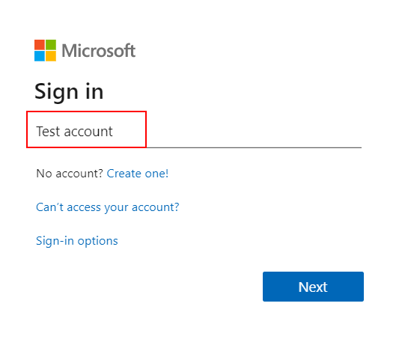

**Note**: Please make sure you have selected the correct environment (with database) when completing the labs. Either use the environment you created in lab 1.1, or the environment provided to you by your instructor. You can switch between different environments by clicking on the environment picker on the title bar.

1. Click Create

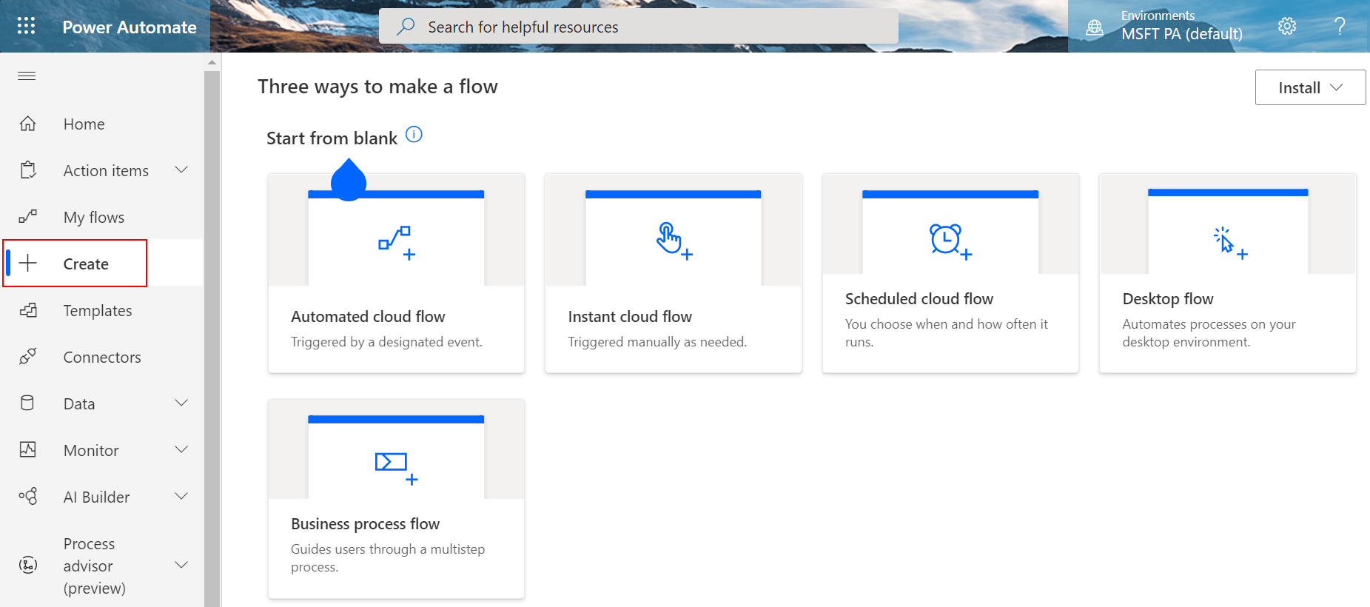

1. Click Automated flow

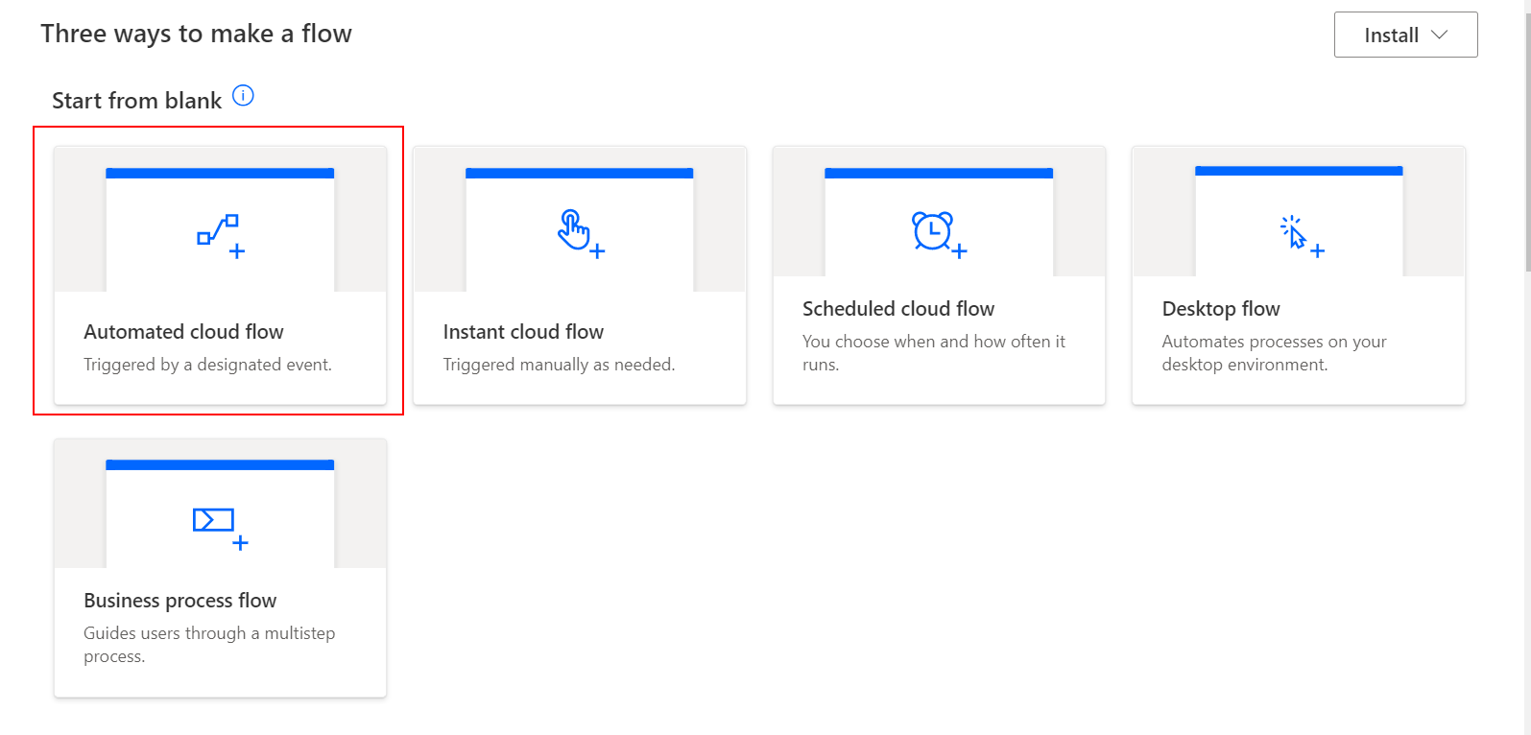

1. Name it Triage incoming requests

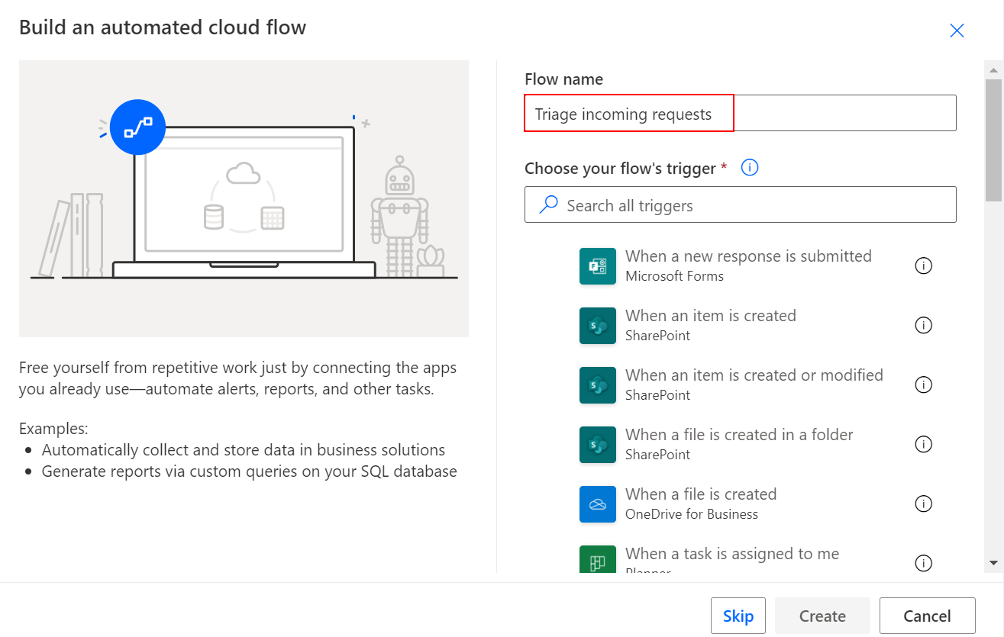

1. Type email under flow’s trigger, and select When a new email arrives (V3)

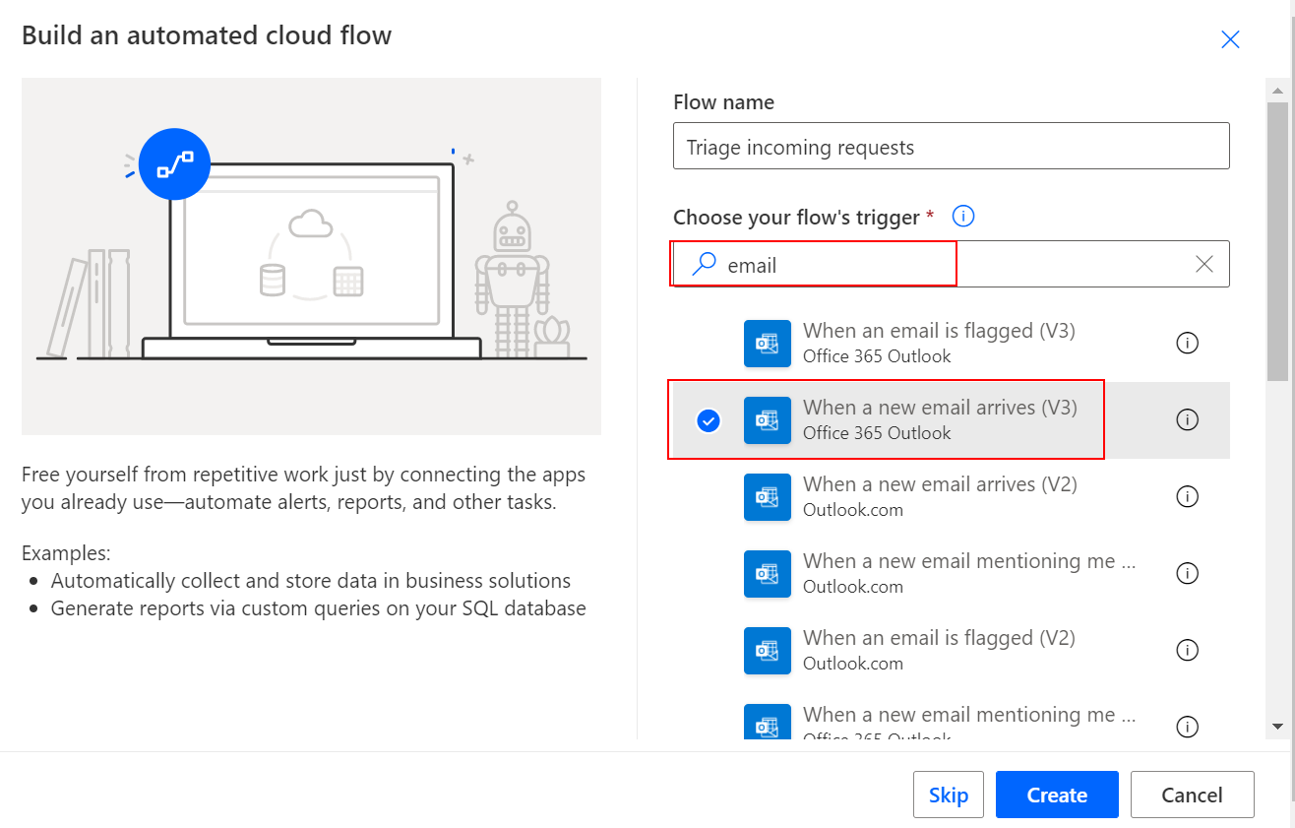

1. Click Create

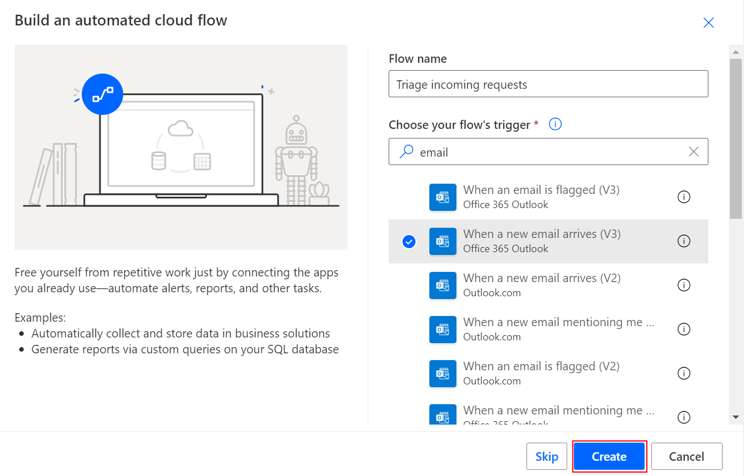

1. Click Show advanced options

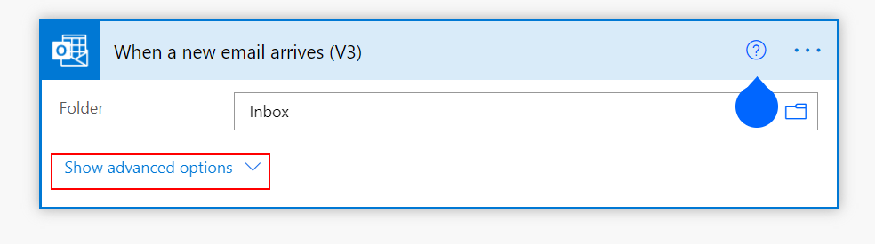

1. Type [Delivery] under Subject Filter

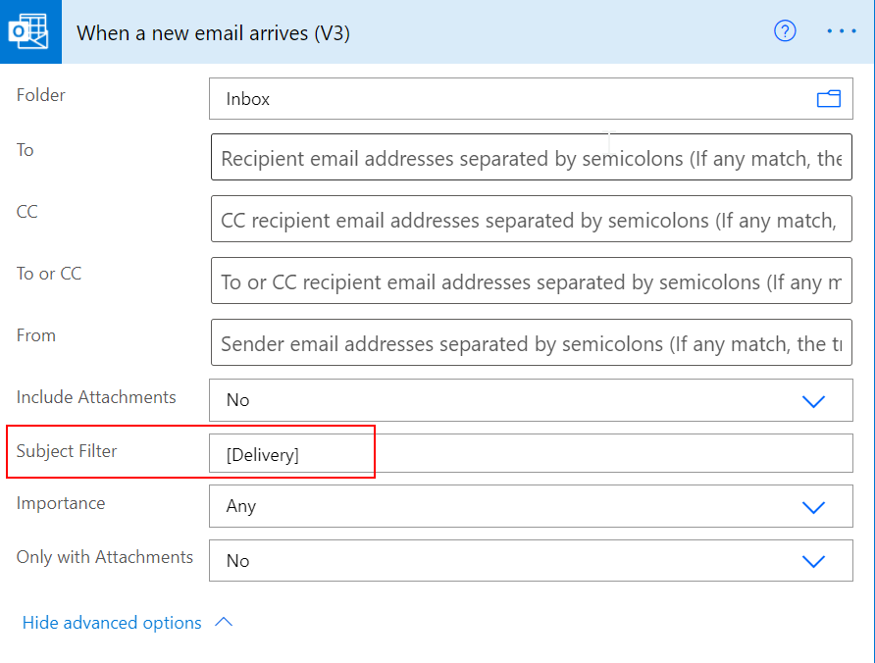

1. Click + New Step

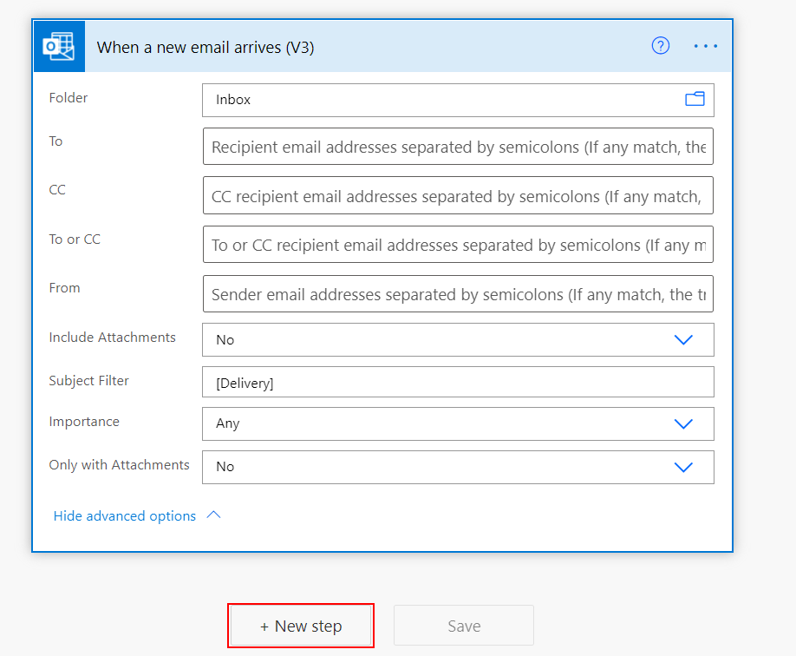

1. Enter desktop flow in the search box and choose Run a flow built with Power Automate Desktop

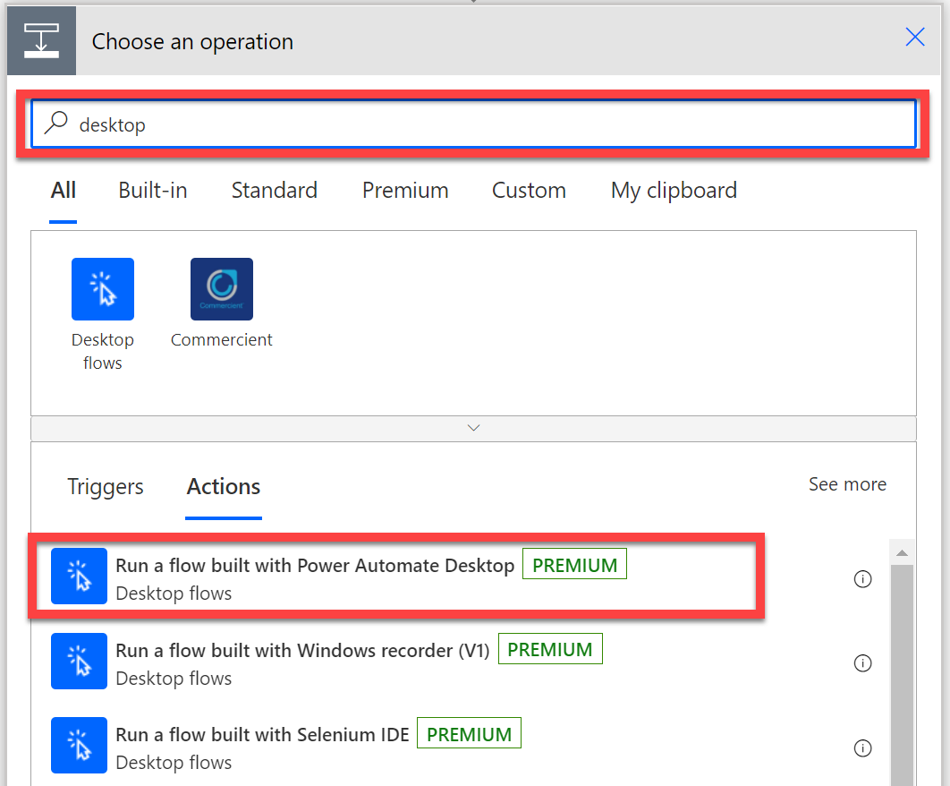

1. Under desktop flow, select Enter an invoice desktop flow

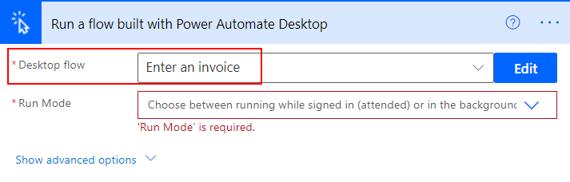

1. Under Run Mode, select unattended – Attended - Runs when you’re signing in

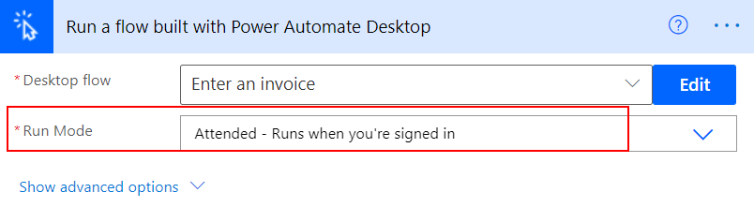

1. Click Show advanced options

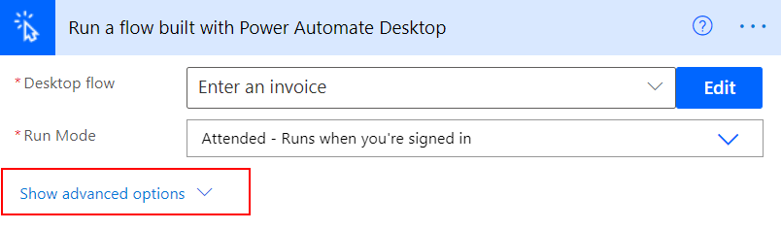

1. Click Priority dropdown

**Note:** Available priorities are High and Normal (the default value). This value can also be passed dynamically using the custom value parameter. Every time the desktop flow is triggered, it will be executed with the priority that has been set

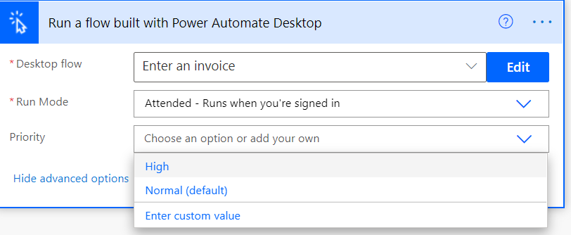

1. Let’s click Enter custom value

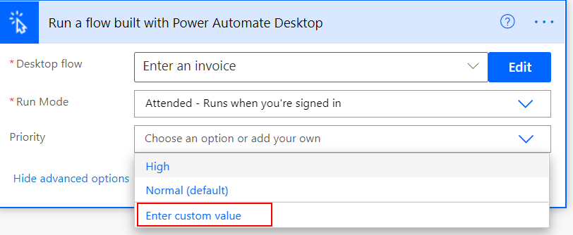

1. Select Importance under Dynamic content

1. Provide values for other fields and click Save

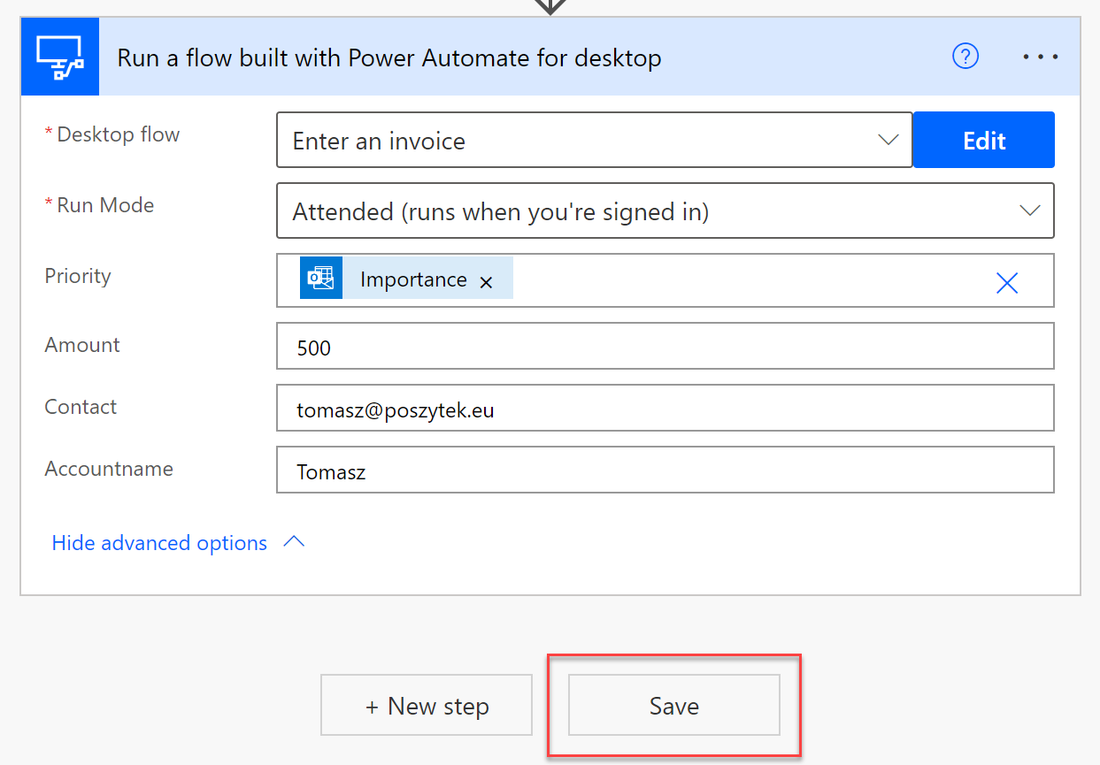

1. Now we can test **Triage incoming requests** cloud flow by sending emails with different importance tags to the email address you have under **My connections**.
2. Open Outlook app, type [Delivery] Enter an invoice Normal Importance in the subject line and send this email with Normal Importance (Don’t select anything under Tags) to the email address that your trigger is monitoring (the connection you used to create your trigger action)

Note: We don’t need to type anything in the body line since this is just for testing purposes.

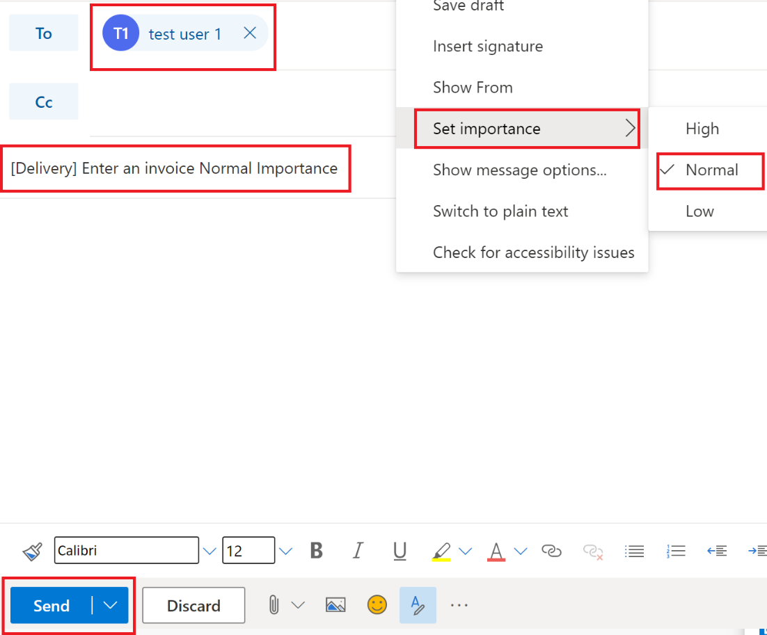

1. Now, let’s go to view the machine run queues. Select Monitor > Machines

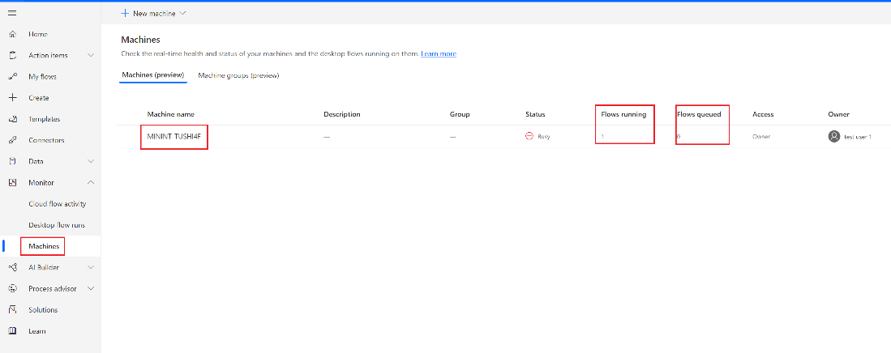

1. Click on the Machine name you have been using for the labs. You will be able to see the desktop flow run details on this machine

1. Now go back to outlook app, and send 3 same emails like the previous one all together
2. Now go back to Monitor-> Machine and click on Run queue under this machine. You can see that there are multiple desktop flow runs being queued on the machine. You can also see the priority field has been labeled as Normal Priority

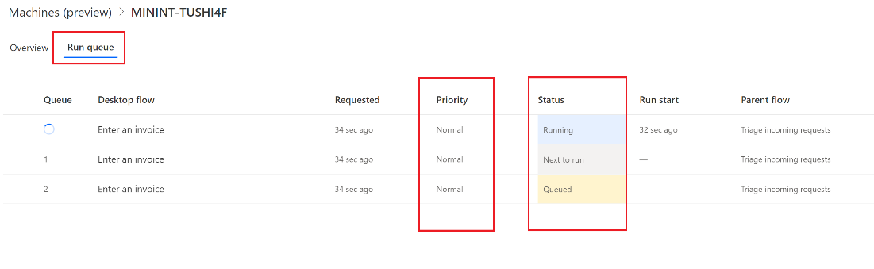

1. Let’s send another email with High Importance. Type [Delivery]Enter an invoice High Importance in the subject line

Note: You can change the Importance of your email to High by selecting High Importance under Tags in your Outlook

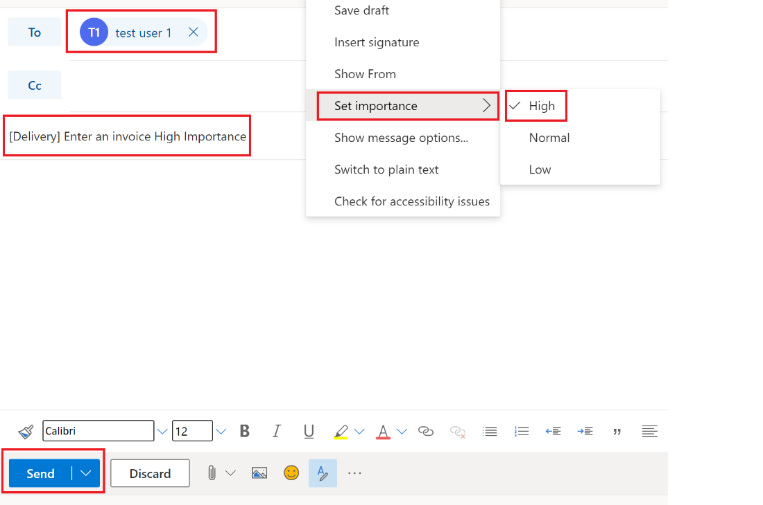

1. You can see under the Run queue, that the priority field has been labeled as **High Priority**

Note: you might have to refresh the page to see this run queue shows up

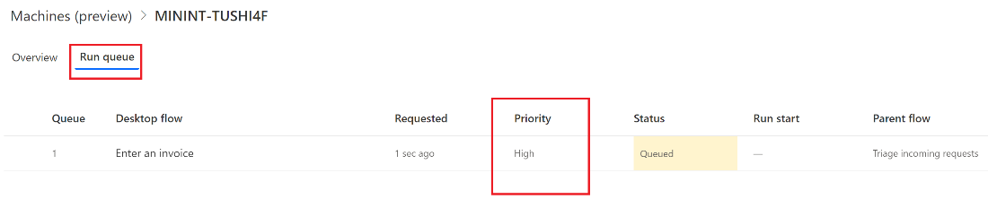

Manage run queue

1. Click on the three dots next to the desktop flow name.

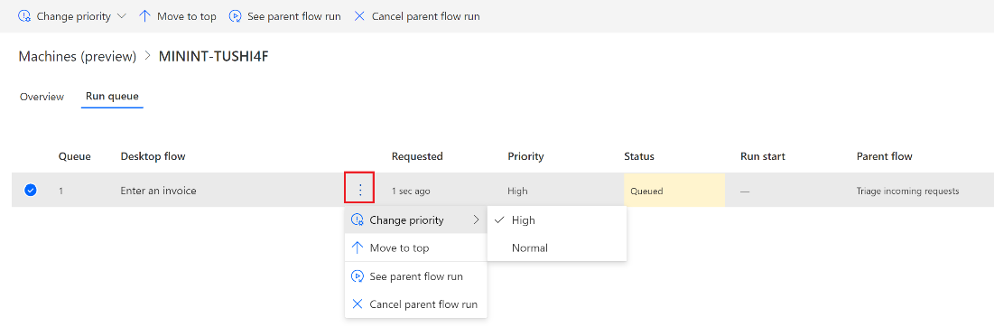

1. You will see four actions are available:

* **Change priority**

You can change the priority of a specific run by clicking on the three dots then Change priority. You can only change the priority of a run of which you are an owner or if you are an admin on the gateway. Changing the priority only impacts the current run and not any subsequent ones. If you wish to change the priority of all the upcoming runs, you need to change the priority in the connector action.

* **Move to top**

The owner of gateway or a user with administrator privileges for the gateway can override the queue priority by moving an item to the top of the queue. That item will be put at the top of the queue regardless of its original priority and queued time. If multiple runs are moved to top, the last one added will be executed first. You can cancel moving a run to top. It will revert the run back to its original priority and queued time.

* **See parent flow run**

If you have permission to access the parent flow, you can use this action to view its run details.

* **Cancel parent flow run**

If you are the owner of the flow, or have the role System Administrator or Environment Admin, you can cancel the parent flow run instance. This will cancel the current desktop flow as well as all the other action that were used in the parent flow.

1. Let’s change one of the desktop flows priorities from Normal to High by clicking Change priority and then select High

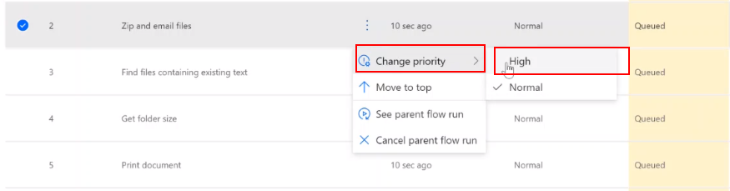

1. You can see that the priority of Zip and email files has changed from Normal to High

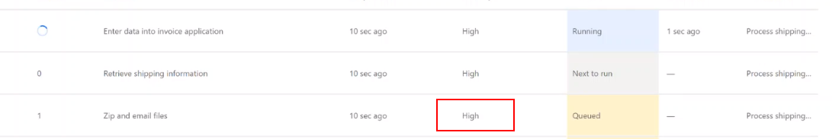

1. Let’s move one of the desktop flows to top by clicking Move to top

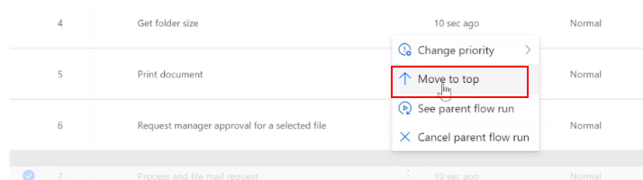

1. You can see that Process and file mail request has move to the top

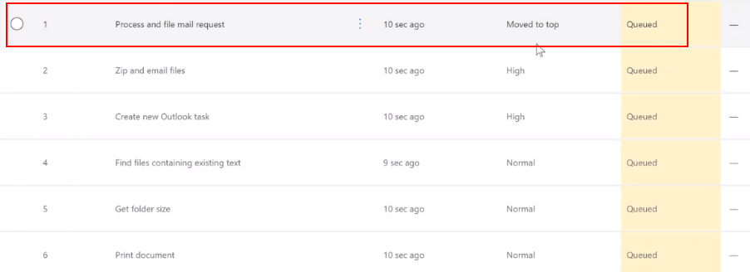

Monitor desktop flow runs

1. We are now going to view desktop flow runs. Select Monitor > Desktop flow runs

1. The following information is available on your runs:

* **Requested** - The time in which the desktop flow was requested by the parent flow. This may not be the same as the time when the desktop flow started running on the machine.
* **Desktop flow** - The name of the desktop flow which was run.
* **Status** - The status of the desktop flow run.
* **Run start** – the time when the desktop flow started running on the machine.
* **Run mode** - The mode in which the desktop flow was run.
* **Machine** – which machine this run is scheduled to
* **Group** – which machine group this run is scheduled to
* **Parent flow** - The cloud flow that triggered the desktop flow to run.

1. You can click the column name to filter them to specific values.

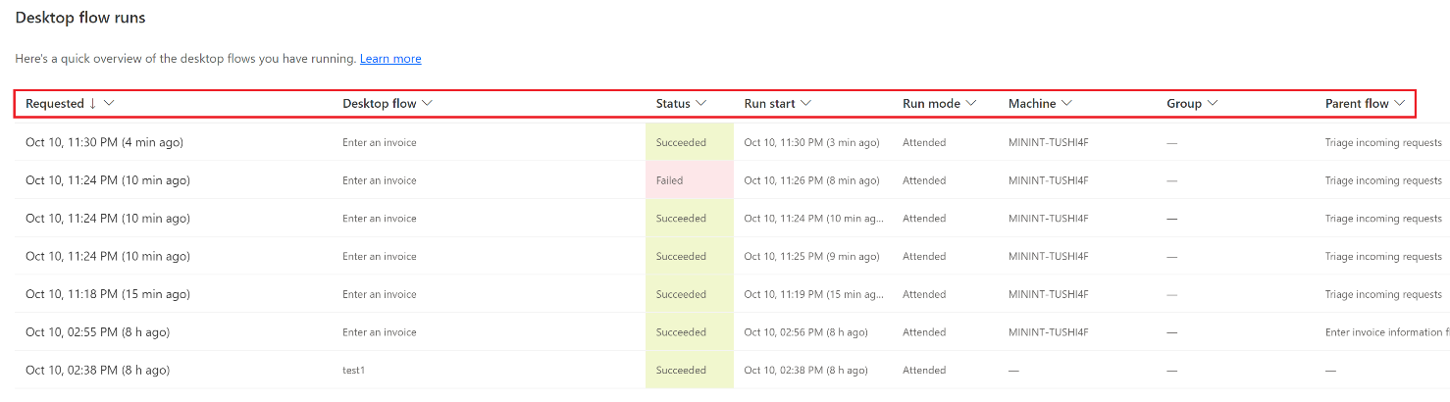

Check your knowledge

Lab 11

5 mins

1. If you send an email with high importance to trigger desktop flow, you will see that the desktop flow will be executed with ______ priority.

1. Low
2. High
3. Normal
4. None of the above

Answer:  High - Available priorities are High and Normal (the default value). This value can also be passed dynamically using the custom value parameter. Every time the desktop flow is triggered, it will be executed with the priority that has been set

1. After clicking the three dots next to the desktop flow name, which of the following allows you to change the priority from high to normal?

1. Change Priority
2. Move to the top
3. See parent flow run
4. Cancel parent flow run

Answer: A. Change Priority - You can change the priority of a specific run by clicking on the three dots then Change priority

1. You can filter your desktop flow runs by Requested time, desktop flow name, Status, Run start time, Run mode and Parent flow.

1. True
2. False

Answer: True

Information in this document, including URL and other Internet Web site references,  
is subject to change without notice. Unless otherwise noted, the example companies, organizations, products, domain names, e-mail addresses, logos, people, places, and events depicted herein are fictitious, and no association with any real company, organization, product, domain name, e-mail address, logo, person, place or event is intended or should be inferred. Complying with all applicable copyright laws is the responsibility of the user. Without limiting the rights under copyright, no part of this document may be reproduced, stored in or introduced into a retrieval system, or transmitted in any form or by any means (electronic, mechanical, photocopying, recording, or otherwise), or for any purpose, without the express written permission of Microsoft Corporation.

Microsoft may have patents, patent applications, trademarks, copyrights, or other intellectual property rights covering subject matter in this document. Except as expressly provided in any written license agreement from Microsoft, the furnishing of this document does not give you any license to these patents, trademarks, copyrights, or other intellectual property.

The names of manufacturers, products, or URLs are provided for informational purposes only and Microsoft makes no representations or warranties, either expressed, implied, or statutory, regarding these manufacturers or the use of the products with any Microsoft technologies.  
The inclusion of a manufacturer or product does not imply endorsement of Microsoft of the manufacturer or product. Links may be provided to third party sites. Such sites are not under the control of Microsoft and Microsoft is not responsible for the contents of any linked site or any link contained in a linked site, or any changes or updates to such sites. Microsoft is not responsible for webcasting or any other form of transmission received from any linked site. Microsoft is providing these links to you only as a convenience, and the inclusion of any link does not imply endorsement of Microsoft of the site or the products contained therein.

© 2021 Microsoft Corporation. All rights reserved.

Microsoft and the trademarks listed at https://www.microsoft.com/enus/legal/intellectualproperty/Trademarks/Usage/General.aspx  
are trademarks of the Microsoft group of companies. All other trademarks are property of their respective owners.